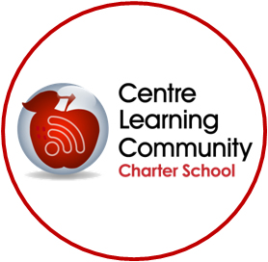
CLC Charter School
2643 W College Ave
State College, PA 16801
814-861-7980

CONSENT FORM

Dear Parent/Guardian,

Your child, _________________________________, has been referred to the CLC Student Assistance Program (SAP). The program provides various support services designed to meet your child’s needs academic, health, and human service needs. A team of school personnel and/or agency professionals will assess your child’s needs and offer appropriate recommendations for in-school and/or out of school services. Please assist us in aiding your child by signing and returning this consent form to the guidance counselor in the enclosed envelope. If you have any further questions or concerns, please contact us. Thank you.

_____________________________________________ I give my permission
(Parent/Guardian Signature)

______________________________________________ I do not give my permission
(Parent/Guardian Signature)

I agree to participate in this program and realize that my parent/guardian must also sign this release as indicated above:

_________________________________________________ ________________________
(Signature of Student) (Date)

_________________________________________________ ________________________
(Signature of SAP team member) (Date)

**This consent shall remain in effect from the date signed until the end of the current school year.

